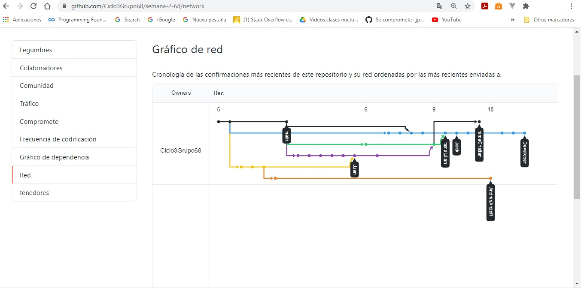

<https://github.com/Ciclo3Grupo68/semana-2-68>